Student ID: 2400090136
Name: MADDA HARSHAVARDHAN REDDYT
Skill Experiment Number: Skill-13
Section Number: 56

TITLE: Deployment of Full-Stack Application
(Spring Boot + React)
CODE:
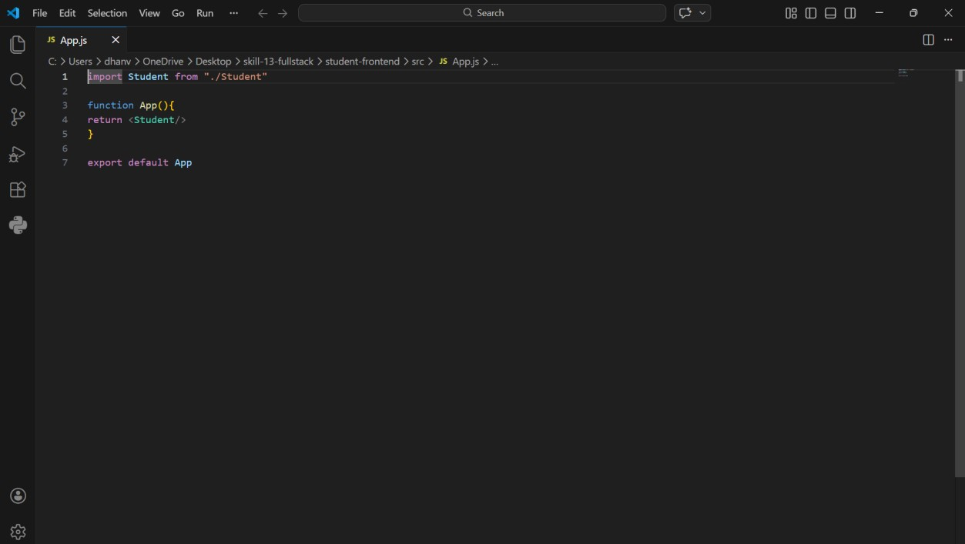
OUTPUT:
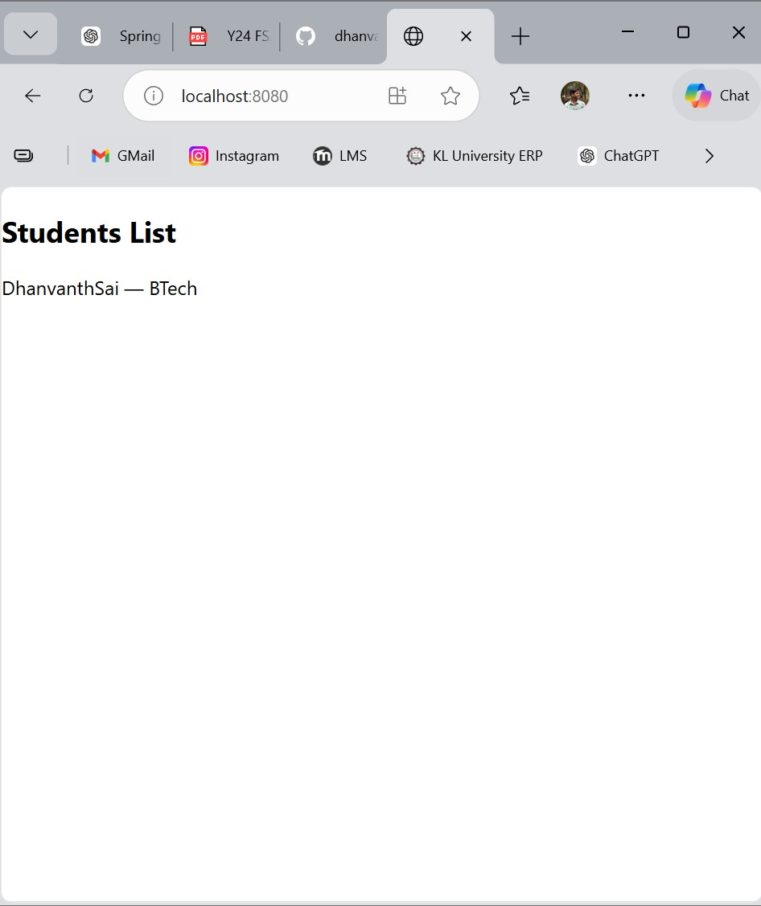
GitHub Repository Link: dhanvanthsaimadamanchi/FullStack-Skill-13-

